PREDICTIVE MODELING AND OPTIMIZATION FOR LOGISTICS OPERATIONS
Project Title: Predictive Modeling and Optimization for Logistics Operations
Domain: Logistics and Supply Chain Analytics
Programming Language: Python
Platform: Google Colab
Libraries: Pandas, NumPy, Matplotlib, Scikit-learn
Prediction Target: Delivery Time in Minutes

1. EXECUTIVE SUMMARY
Logistics organizations need accurate delivery-time predictions to improve route planning, driver allocation, vehicle utilization, scheduling, and customer satisfaction. This project applies predictive modeling and optimization techniques to a logistics delivery-time forecasting problem.
A simulated logistics dataset containing 1,500 shipment records was generated using Python. The dataset contains operational features such as distance, traffic level, weather conditions, package weight, vehicle type, driver experience, number of stops, and hour of day.
Two predictive models were developed and evaluated:
- Linear Regression
- Random Forest Regression
The models were evaluated using Mean Absolute Error (MAE), Root Mean Squared Error (RMSE), and R² Score.
Based on the executed test results, Linear Regression achieved the best predictive performance with:
- MAE: 6.22 minutes
- RMSE: 7.60 minutes
- R²: 0.9579
Random Forest achieved:
- MAE: 9.45 minutes
- RMSE: 11.87 minutes
- R²: 0.8972
Five-fold cross-validation and GridSearchCV were also performed for the Random Forest model. Feature-importance analysis showed that Distance_KM was the most influential feature, followed by Stop_Count.
The predictions were then translated into practical logistics optimization strategies including dynamic driver allocation, traffic-aware scheduling, route prioritization, vehicle matching, stop consolidation, proactive customer communication, and resource planning.

2. INTRODUCTION
The logistics industry handles large volumes of shipments every day. Delivery performance depends on several factors including transportation distance, traffic congestion, weather conditions, vehicle characteristics, driver experience, number of delivery stops, and dispatch timing.
Unexpected delays can increase transportation costs and negatively affect customer satisfaction.
Predictive analytics can help logistics organizations estimate delivery times before shipments are completed. By identifying shipments that are likely to experience longer delivery times, organizations can take preventive actions.
This project demonstrates how machine learning can be applied to predict delivery time and how predictive insights can be converted into logistics optimization strategies.

3. PROBLEM STATEMENT
The main problem addressed in this project is:
"How can machine learning be used to predict logistics delivery time and support operational optimization?"
The project aims to:
- Simulate a realistic logistics dataset.
- Analyze important factors affecting delivery time.
- Develop predictive models for delivery-time forecasting.
- Compare different machine-learning models.
- Evaluate model performance using appropriate metrics.
- Validate and tune the selected models.
- Identify important operational factors.
- Classify shipments according to predicted delay risk.
- Propose optimization strategies based on model predictions.

4. OBJECTIVES
The major objectives of the project are:
- To develop a predictive model for logistics delivery time.
- To understand the factors affecting delivery duration.
- To compare Linear Regression and Random Forest Regression.
- To evaluate models using MAE, RMSE, and R².
- To perform five-fold cross-validation.
- To perform hyperparameter tuning using GridSearchCV.
- To identify important logistics features.
- To identify potentially high-risk deliveries.
- To propose practical logistics optimization strategies.

5. DATASET DESCRIPTION
A simulated dataset containing 1,500 logistics shipment records was generated using Python.
The dataset contains the following variables:
Feature | Type | Description
Distance_KM | Numerical | Distance travelled by the shipment
Traffic_Level | Categorical | Low, Medium, or High traffic
Weather | Categorical | Clear, Rain, or Storm
Package_Weight_KG | Numerical | Weight of the package
Vehicle_Type | Categorical | Bike, Van, or Truck
Driver_Experience_Years | Numerical | Experience of the delivery driver
Stop_Count | Numerical | Number of delivery stops
Hour_of_Day | Numerical | Hour when delivery operation takes place
Peak_Hour | Derived | Indicates whether the shipment occurs during peak hours
Delivery_Time_Minutes | Target | Actual delivery duration
The target variable used for prediction was:
Delivery_Time_Minutes

6. DATA SIMULATION
The dataset was simulated using NumPy and pandas.
The delivery time was generated using multiple operational factors, including:
- Travel distance
- Package weight
- Number of stops
- Driver experience
- Traffic conditions
- Weather conditions
- Vehicle type
- Peak-hour effects
- Random variation
This allowed the project to demonstrate the complete predictive modeling workflow even without access to confidential real-world logistics data.

7. TOOLS AND TECHNOLOGIES USED
The following technologies were used:
Programming Language
Python
Development Environment
Google Colab
Libraries
- Pandas
- NumPy
- Matplotlib
- Scikit-learn
Machine Learning Techniques
- Linear Regression
- Random Forest Regression
- Cross-Validation
- GridSearchCV
- Feature Importance Analysis

8. DATA QUALITY CHECK
The dataset was checked before model development.
The executed analysis showed:
- Number of records: 1,500
- Original number of columns: 9
- Missing values: 0
- Duplicate records: 0
Therefore, no missing-value imputation or duplicate removal was required.
The data types were also inspected to distinguish between numerical and categorical variables.

9. EXPLORATORY DATA ANALYSIS
Exploratory Data Analysis was performed to understand the distribution of delivery times and relationships between logistics variables.
9.1 Delivery Time Distribution
The delivery-time values ranged approximately from:
16.02 minutes to 235.49 minutes
The mean delivery time was approximately:
118.54 minutes
The standard deviation was approximately:
37.83 minutes
The distribution plot was created using Matplotlib.
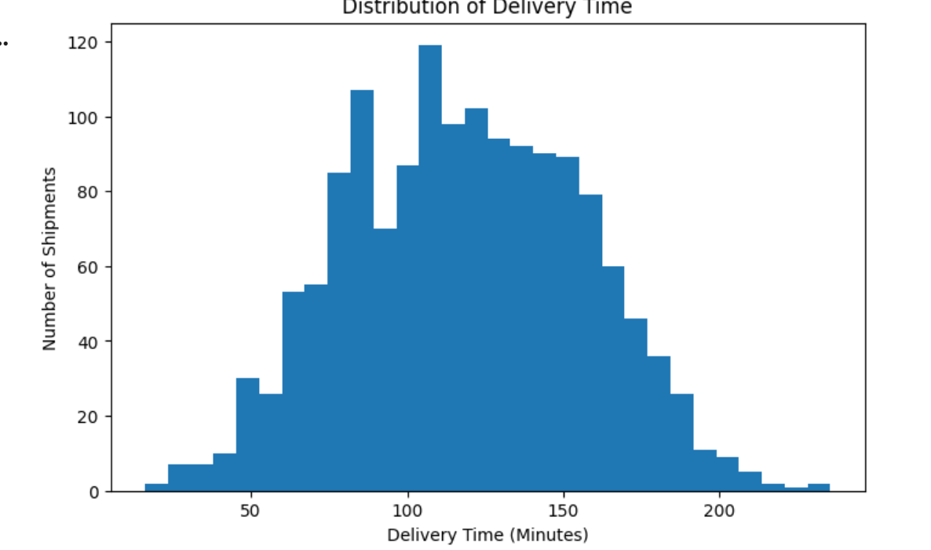

10. DISTANCE AND DELIVERY TIME ANALYSIS
Distance was found to have the strongest numerical relationship with delivery time.
The correlation between distance and delivery time was approximately:
0.8176
This indicates a strong positive relationship.
As the delivery distance increases, the expected delivery time generally increases.
This finding is important for logistics planning because long-distance shipments require greater attention to route planning, vehicle allocation, and scheduling.
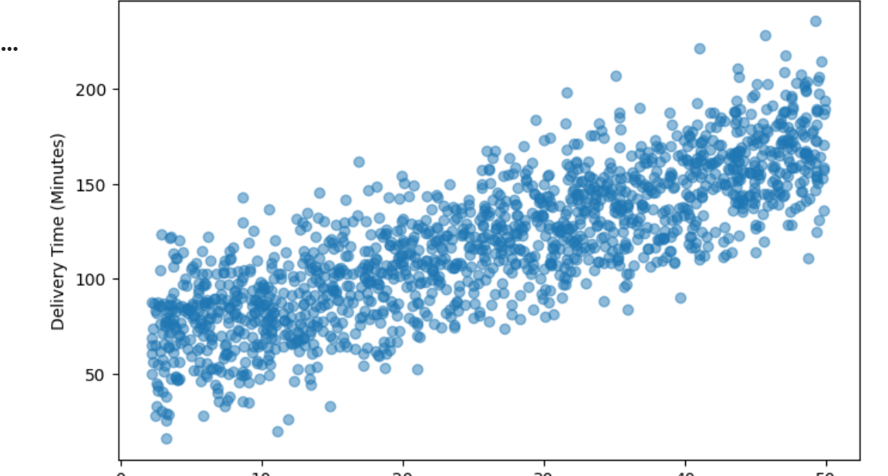

11. TRAFFIC ANALYSIS
Average delivery time was analyzed according to traffic level.
The executed analysis produced approximately:
Traffic Level | Average Delivery Time
Low | 106.74 minutes
Medium | 118.06 minutes
High | 135.37 minutes
The results indicate that higher traffic levels are associated with longer delivery times.
Therefore, traffic information can be incorporated into delivery scheduling and route planning.
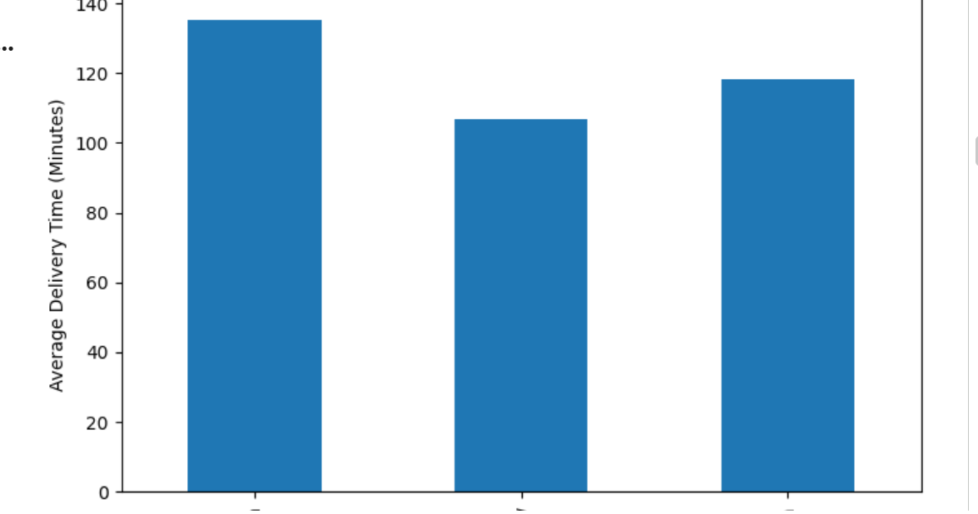

12. VEHICLE ANALYSIS
Average delivery time was also analyzed according to vehicle type.
The executed analysis produced approximately:
Vehicle Type | Average Delivery Time
Bike | 112.86 minutes
Van | 119.66 minutes
Truck | 126.10 minutes
This indicates that vehicle type is another factor associated with delivery duration.
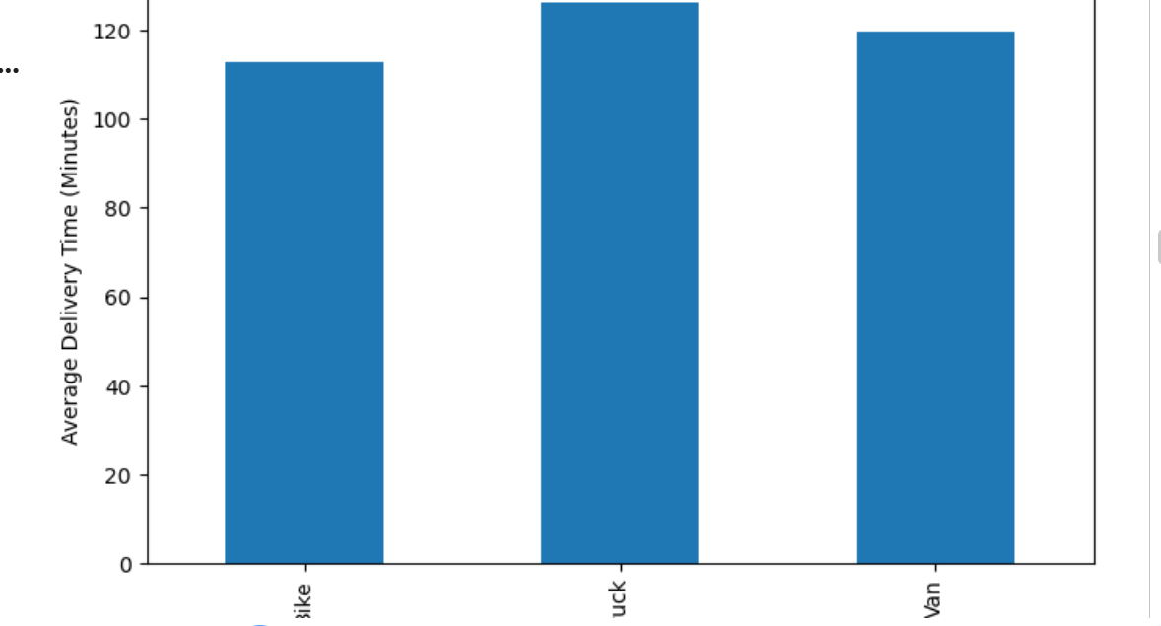

13. CORRELATION ANALYSIS
The correlation analysis identified the following relationships with delivery time:
Feature | Correlation
Distance_KM | 0.8176
Stop_Count | 0.3043
Package_Weight_KG | 0.0845
Hour_of_Day | 0.0388
Driver_Experience_Years | -0.1082
Distance showed the strongest positive relationship with delivery time.
Stop count was the second most relevant numerical factor.
Driver experience showed a negative relationship, suggesting that more experienced drivers may complete deliveries more efficiently in the simulated environment.
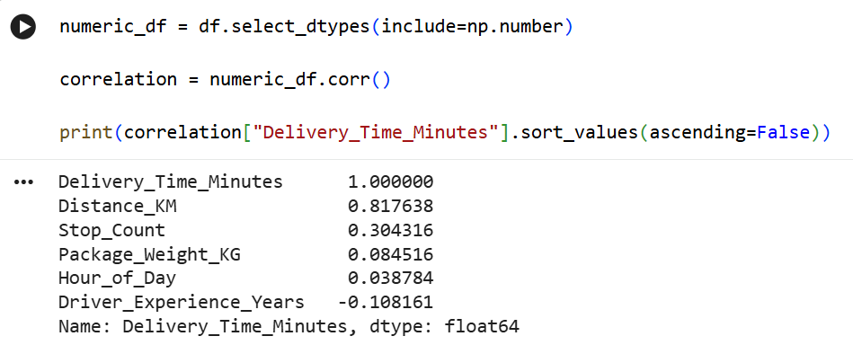

14. FEATURE ENGINEERING
A new feature named Peak_Hour was created.
Peak hours were defined as:
- 08:00–10:00
- 17:00–20:00
The feature was encoded as:
- 1 = Peak Hour
- 0 = Non-Peak Hour
This feature helps the model account for potential congestion and operational pressure during busy periods.

15. DATA PREPROCESSING
The dataset was divided into:
- 80% training data
- 20% testing data
A random state of 42 was used to ensure reproducibility.
Categorical variables were:
- Traffic_Level
- Weather
- Vehicle_Type
These variables were transformed using OneHotEncoder.
Numerical variables were passed through the preprocessing pipeline without scaling.
A Scikit-learn Pipeline was used to combine preprocessing and model training.

16. MODEL SELECTION
Two regression algorithms were selected.
16.1 Linear Regression
Linear Regression was selected as the baseline model because it is:
- Simple
- Interpretable
- Computationally efficient
- Easy to evaluate
- Suitable for establishing a baseline performance
16.2 Random Forest Regression
Random Forest Regression was selected because it can:
- Capture nonlinear relationships
- Model interactions between variables
- Handle mixed feature types after preprocessing
- Provide feature-importance information
- Provide a strong ensemble-based comparison against the baseline model

17. MODEL EVALUATION METRICS
Three evaluation metrics were used.
Mean Absolute Error (MAE)
MAE measures the average absolute difference between actual and predicted delivery time.
A lower MAE indicates better performance.
Root Mean Squared Error (RMSE)
RMSE measures prediction error while giving greater weight to larger errors.
A lower RMSE indicates better performance.
R² Score
R² measures how much variation in the target variable is explained by the model.
A value closer to 1 indicates better explanatory performance.

18. LINEAR REGRESSION RESULTS
The executed Linear Regression model produced:
Metric | Result
MAE | 6.22 minutes
RMSE | 7.60 minutes
R² | 0.9579
The model therefore predicted delivery times with an average absolute error of approximately 6.22 minutes.
The R² value of 0.9579 indicates that approximately 95.79% of the variation in the simulated delivery-time target was explained by the model.
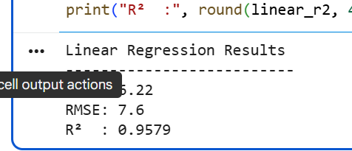

19. RANDOM FOREST RESULTS
The executed Random Forest model produced:
Metric | Result
MAE | 9.45 minutes
RMSE | 11.87 minutes
R² | 0.8972
Although Random Forest was useful for nonlinear analysis and feature importance, Linear Regression achieved better predictive performance on this particular simulated dataset.
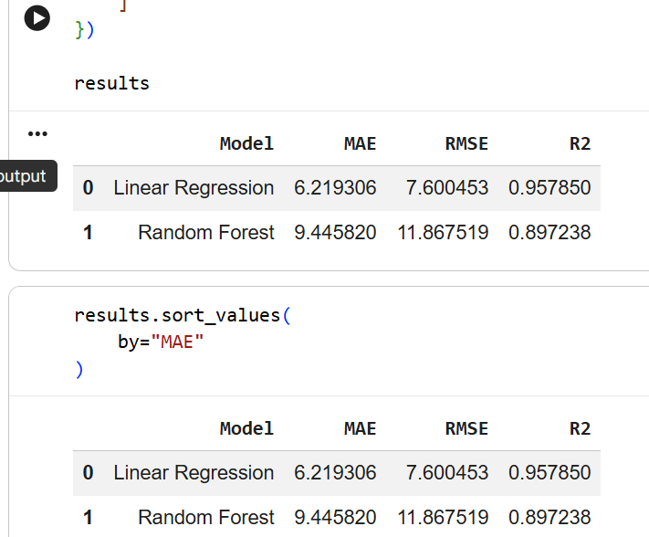

20. MODEL COMPARISON
Model | MAE | RMSE | R²
Linear Regression | 6.22 | 7.60 | 0.9579
Random Forest | 9.45 | 11.87 | 0.8972
Interpretation
Linear Regression achieved:
- Lower MAE
- Lower RMSE
- Higher R²
Therefore, Linear Regression was the best-performing predictive model on the executed test set.
However, Random Forest remained valuable for understanding nonlinear patterns and feature importance.

21. CROSS-VALIDATION
Five-fold cross-validation was performed on the Random Forest pipeline.
The fold MAE results were approximately:
- Fold 1: 9.48
- Fold 2: 9.52
- Fold 3: 9.80
- Fold 4: 9.93
- Fold 5: 9.84
The average cross-validation MAE was approximately:
9.71 minutes
The standard deviation was approximately:
0.18 minutes
The relatively small variation between folds indicates stable validation performance for the Random Forest model on the simulated dataset.
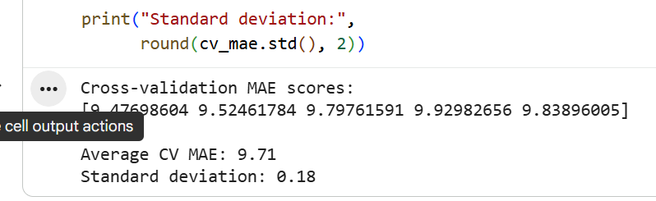

22. HYPERPARAMETER TUNING
GridSearchCV was used to optimize the Random Forest model.
The following parameters were tested:
- Number of estimators
- Maximum tree depth
- Minimum samples per leaf
The best configuration identified was:
Parameter | Best Value
n_estimators | 200
max_depth | 20
min_samples_leaf | 1
The best cross-validation MAE was approximately:
9.71 minutes
This demonstrates the use of systematic hyperparameter optimization instead of relying only on default model settings.

23. ACTUAL VS PREDICTED ANALYSIS
The project compared actual delivery times with predicted delivery times.
The purpose of this visualization was to determine how closely the model's predictions followed the actual values.
A prediction scatter plot was created using the test dataset.
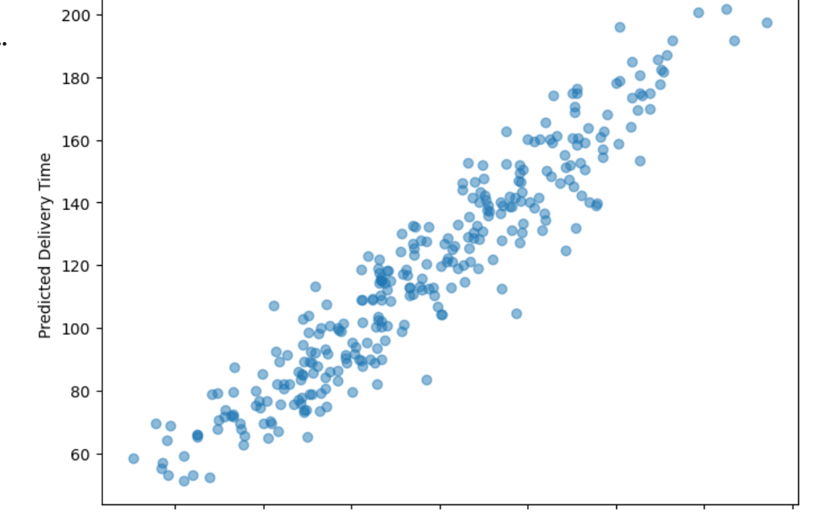
A strong concentration of observations around the expected prediction trend indicates better predictive agreement.

24. PREDICTION ERROR ANALYSIS
Prediction errors were calculated as:
Actual Delivery Time − Predicted Delivery Time
An error-distribution histogram was created to understand the behavior of prediction errors.
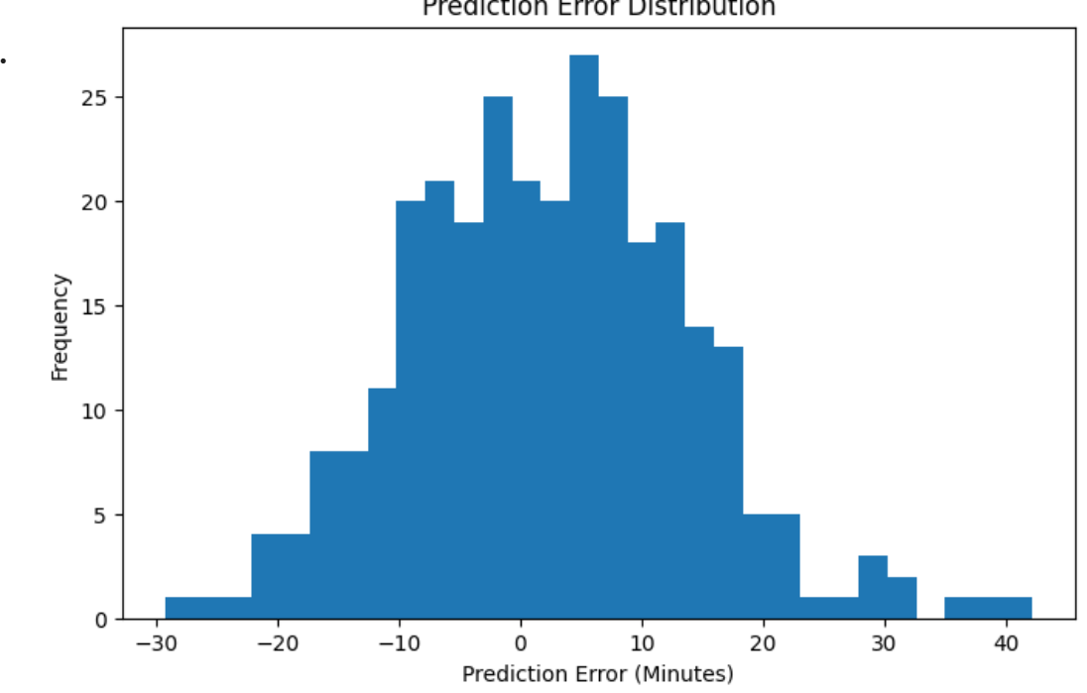
This analysis helps identify whether the model produces systematic overprediction or underprediction.

25. FEATURE IMPORTANCE ANALYSIS
Feature importance was calculated using the Random Forest model.
The most important features were:
Feature | Importance
Distance_KM | 0.6999
Stop_Count | 0.1209
Traffic_Level_High | 0.0323
Traffic_Level_Low | 0.0308
Driver_Experience_Years | 0.0216
Package_Weight_KG | 0.0216
Peak_Hour | 0.0206
Hour_of_Day | 0.0133
Weather_Clear | 0.0130
Weather_Storm | 0.0103
Key Insight
Distance_KM was by far the most influential feature, with an importance of approximately 0.6999.
Stop count was the second most important feature.
This suggests that logistics managers should give particular attention to route distance and the number of delivery stops when planning operations.
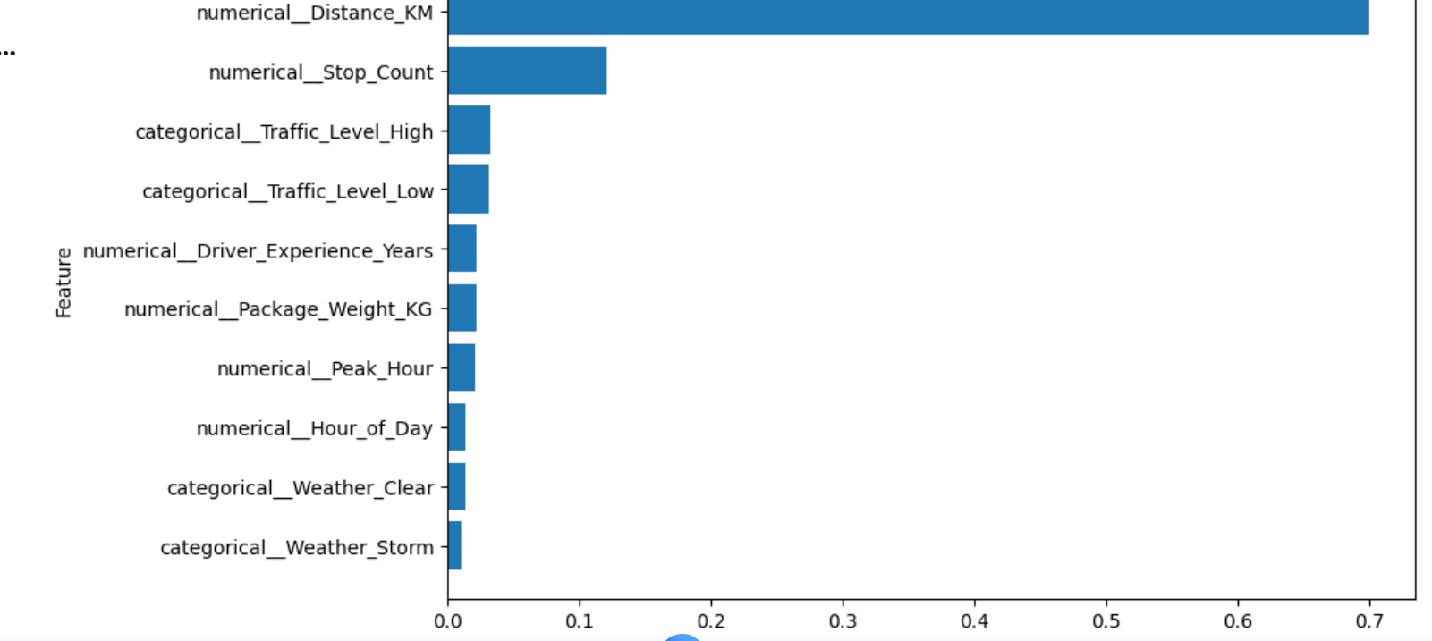

26. DELAY-RISK ANALYSIS
The model predictions were used to classify shipments into two categories.
High Risk
Predicted delivery time:
Greater than 100 minutes
Normal
Predicted delivery time:
100 minutes or less
Within the 300 test shipments:
- 196 shipments were classified as High Risk
- 104 shipments were classified as Normal
This demonstrates how predictive modeling can be converted into an operational decision-support system.
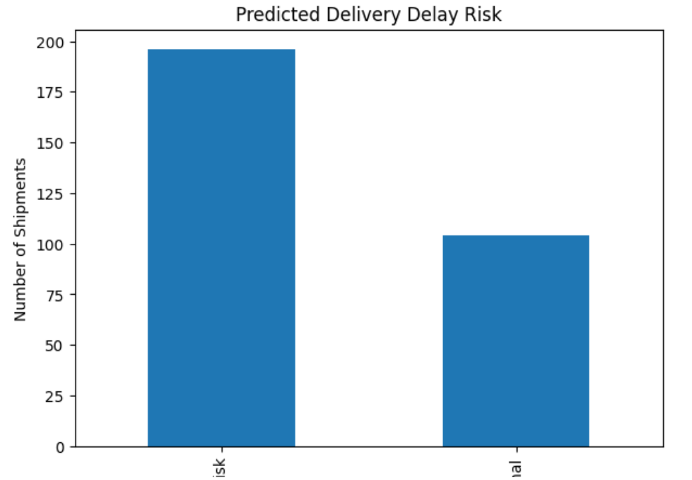

27. LOGISTICS OPTIMIZATION STRATEGIES
The predictive model can be used to improve logistics operations in several ways.
27.1 Dynamic Driver Allocation
High-risk shipments can receive priority when assigning available drivers.
Drivers with appropriate availability and experience can be assigned to routes with higher predicted delivery times.
Expected benefit:
- Better workload distribution
- Reduced delay risk
- Improved driver utilization

27.2 Traffic-Aware Scheduling
The analysis showed that high traffic was associated with longer delivery times.
Shipments predicted to encounter high traffic can be dispatched earlier or scheduled during less congested periods where operationally possible.
Expected benefit:
- Reduced traffic-related delays
- Better delivery predictability
- Improved scheduling efficiency

27.3 Route Prioritization
Distance was the most important predictive feature.
Long-distance routes should therefore receive additional planning attention.
Alternative routes can be evaluated for shipments with particularly high predicted delivery times.
Expected benefit:
- Reduced travel time
- Better route planning
- Lower delay probability

27.4 Vehicle Matching
Vehicle allocation should consider:
- Distance
- Package weight
- Route characteristics
- Expected delivery duration
This can improve fleet utilization.

27.5 Stop Consolidation
The analysis identified Stop_Count as the second most important Random Forest feature.
Nearby deliveries can be grouped into efficient delivery sequences to reduce unnecessary travel.
Expected benefit:
- Lower travel distance
- Lower fuel consumption
- Reduced delivery time

27.6 Proactive Customer Communication
Shipments classified as high risk can trigger proactive customer communication.
Customers can be informed about potential delays before the expected delivery time is missed.
Expected benefit:
- Improved customer satisfaction
- Better transparency
- Reduced complaints

27.7 Resource Planning
Predicted delivery times can be aggregated by:
- Hour
- Route
- Vehicle
- Driver
- Traffic condition
This information can help logistics managers plan staffing and fleet requirements.

28. OPTIMIZATION WORKFLOW
The proposed logistics decision-making workflow is:
Shipment Data
↓
Data Cleaning and Preprocessing
↓
Predict Delivery Time
↓
Identify High-Risk Shipments
↓
Prioritize Drivers and Routes
↓
Optimize Scheduling and Vehicle Allocation
↓
Monitor Actual Delivery Performance
↓
Compare Actual vs Predicted Results
↓
Retrain Model with New Data
This workflow demonstrates how predictive analytics can support continuous logistics improvement.

29. PYTHON IMPLEMENTATION
The project was implemented using Python in Google Colab.
The main stages of the implementation were:
# Data preparation
X = df.drop(columns=["Delivery_Time_Minutes"])
y = df["Delivery_Time_Minutes"]

# Train-test split
X_train, X_test, y_train, y_test = train_test_split(
X, y,
test_size=0.20,
random_state=42
)

# Model training
linear_model.fit(X_train, y_train)
rf_model.fit(X_train, y_train)

# Prediction
predictions = rf_model.predict(X_test)

# Evaluation
mae = mean_absolute_error(y_test, predictions)
rmse = np.sqrt(mean_squared_error(y_test, predictions))
r2 = r2_score(y_test, predictions)
The complete executable code is included in the associated Google Colab notebook and will be uploaded to GitHub.

30. BUSINESS INSIGHTS
The analysis produced several important logistics insights.
Insight 1
Distance is the most influential factor affecting delivery time.
Insight 2
Higher traffic levels are associated with longer delivery times.
Insight 3
The number of delivery stops has a significant influence on delivery duration.
Insight 4
Peak-hour information can be incorporated into predictive modeling.
Insight 5
Machine-learning predictions can be transformed into delivery-risk categories.
Insight 6
Predictive insights can support driver allocation, scheduling, routing, and customer communication.

31. LIMITATIONS
The primary limitation of this project is that the dataset is simulated.
Therefore, the model performance should be considered a demonstration of the predictive analytics methodology rather than production-level accuracy.
A real logistics implementation should incorporate:
- Historical delivery records
- GPS data
- Real-time traffic information
- Weather information
- Warehouse processing times
- Vehicle capacity
- Driver availability
- Route constraints
- Delivery priority
- Customer location
- Historical delay information
Future work could also integrate advanced vehicle-routing and optimization algorithms.

32. FUTURE ENHANCEMENTS
Future versions of this project could include:
- Real-world logistics datasets.
- Real-time traffic APIs.
- GPS-based route information.
- Advanced vehicle-routing algorithms.
- XGBoost or Gradient Boosting models.
- Time-series forecasting.
- Real-time delivery dashboards using Power BI or Tableau.
- Automated delay alerts.
- Dynamic route optimization.
- Cost-minimization optimization.

33. CONCLUSION
This project successfully demonstrated the application of predictive modeling and optimization techniques to a logistics delivery-time forecasting problem.
A simulated dataset containing 1,500 shipment records was created and analyzed.
Two machine-learning approaches were evaluated:
- Linear Regression
- Random Forest Regression
Linear Regression achieved the best test performance with:
MAE = 6.22 minutes
RMSE = 7.60 minutes
R² = 0.9579
Random Forest achieved:
MAE = 9.45 minutes
RMSE = 11.87 minutes
R² = 0.8972
Cross-validation and GridSearchCV were used to improve the reliability of the modeling process.
Feature-importance analysis showed that Distance_KM was the dominant factor, followed by Stop_Count.
The predictive results were translated into actionable logistics strategies including dynamic driver allocation, traffic-aware scheduling, route prioritization, vehicle matching, stop consolidation, proactive customer communication, and resource planning.
Although the dataset is simulated, the project demonstrates an end-to-end machine-learning workflow that can be adapted to real logistics operations.

